CHAPTER-3

MATHEMATICAL MODELLING OF LOAD FREQUENCY CONTROL SYSTEMS INTEGRATED WITH EV AGGREGATOR

**INTRODUCTION:**

The design and implementation of load frequency control systems integrated with Electric Vehicle Aggregator need to be supported by a holistic understanding of their functional processes, their interactions, and their responses to various changes. Models developed to represent different functional processes and the systems are seen as useful tools to support the related studies for different stakeholders in a tangible way. This chapter presents an overview of modeling approaches applied to support aggregation of EVs with Load Frequency Control System. As already known,in the integrated electrical systems,frequency control service considering the Electric Vehicle (EV) aggregators could lead to time variable delay in Load Frequency Control Schemes. Thus, this chapter illustrates different time-variable delays result based on the stability of an LFC system in the presence of the EV aggregators. Primarily, a graphical method characterizing the stability boundary locus is implemented. For a given time delay, the method computes all the stabilizing proportional-integral(PI) controller gains, which constitutes a stability region in the parameter space of PI controller. Secondly, in order to complement the stability regions a frequency-domain exact method is used to calculate stability delay margins for various values of PI controller gains. The impact of EV aggregator on both stability regions and stability delay margins is thoroughly analyzed and the results are authenticated by the usage of visual programming(MATLAB) and time domain simulation.

**3.1 MATHEMATICAL MODELLING OF LFC SYSTEM WITH EV AGGREGATOR:**

The block diagram of a single area LFC system including an EV aggregator and delay block is presented in Fig.1

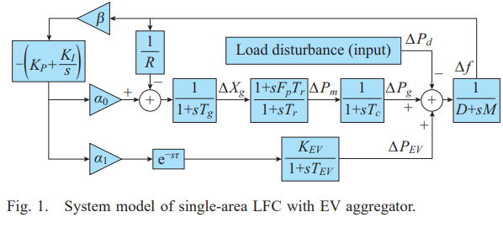The PI type controller is adopted as LFC controller. In Fig.1, Δf,ΔXg,ΔPm, ΔPEV and ΔPd are the deviation of frequency, valve position, mechanical power output, generator power output, EV aggregator power output and load disturbance, respectively; D,M,R,β,Fp,Tg,Tr and Tc are the damping coefficient,generator inertia constant, speed drop, frequency bias factor, fraction of the total turbine power, time constant of the governor, reheat and turbine, respectively; and KP and KI are the PI controller gains.

The imbalance between demand and generation is measured in terms of incremental frequency variable Δf. The incremental variable is fed back to PI controller which sends appropriate control effect to the governor. The governor decides the valve opening of the turbine for increasing input of the synchronous generator. The constant action restores the imbalance between generator and demand. The fleet of Electric Vehicles called Ev aggregator connected through communication network and the conventional power system restores the frequency imbalance brought about by load variation. The load sharing between the conventional power system and EV aggregator is taken care using participation factors α0 and α1.

**3.1.2) VARIABLE DESCRIPTION:**

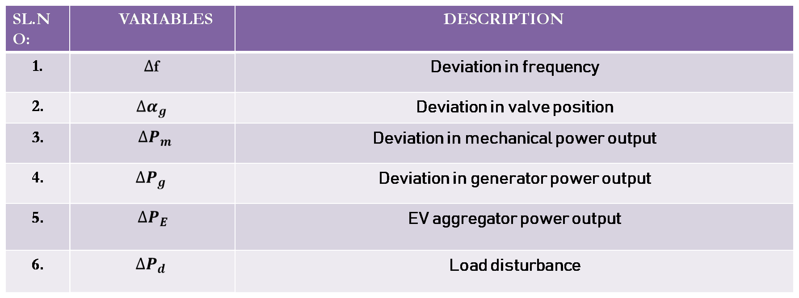

**3.1.3) PARAMETER DESCRIPTION:**

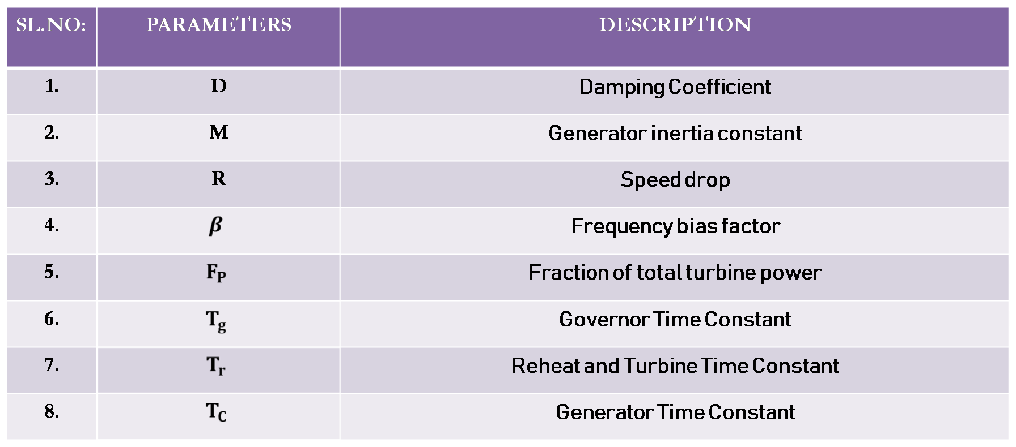

**3.1.4) CONTROLLER PARAMETERS AND PARTICIPATION FACTORS:**

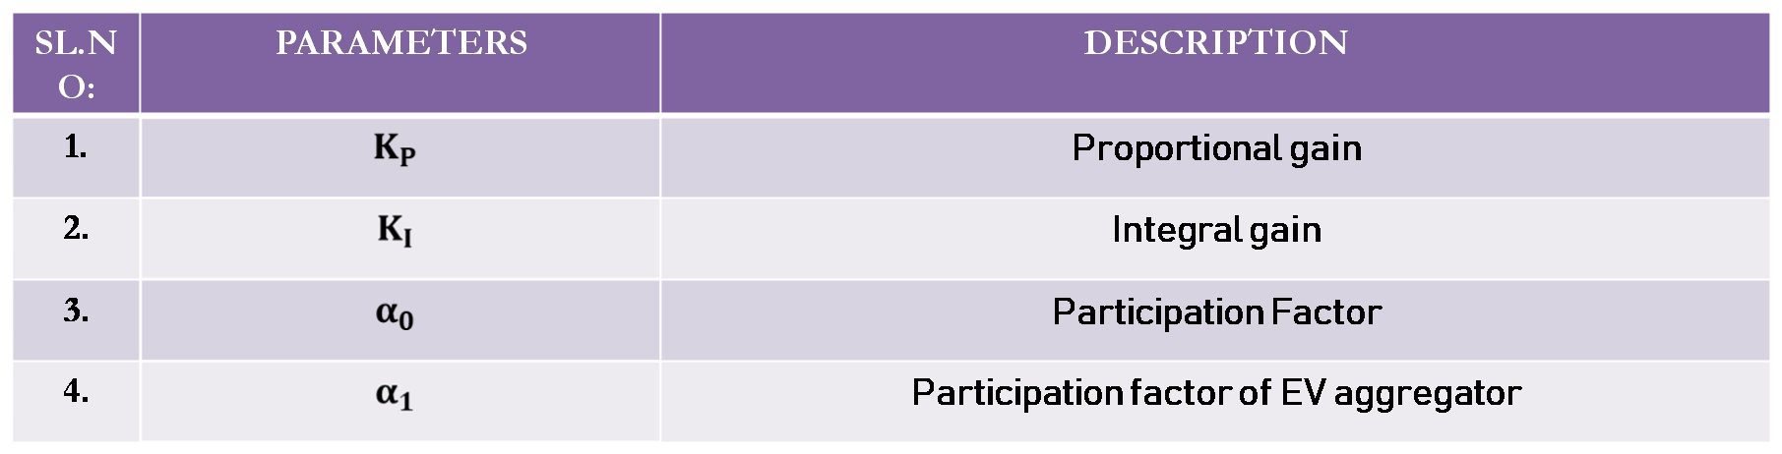

**3.1.5) EV AGGREGATOR PARAMETERS:**

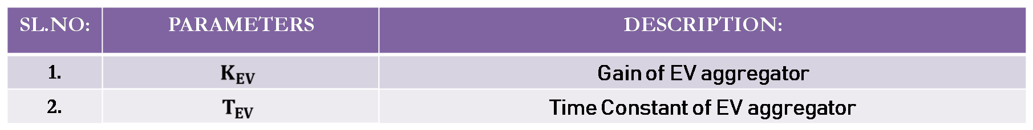

For mathematical modeling purpose, the LFC system is illustrated as Fig.2,

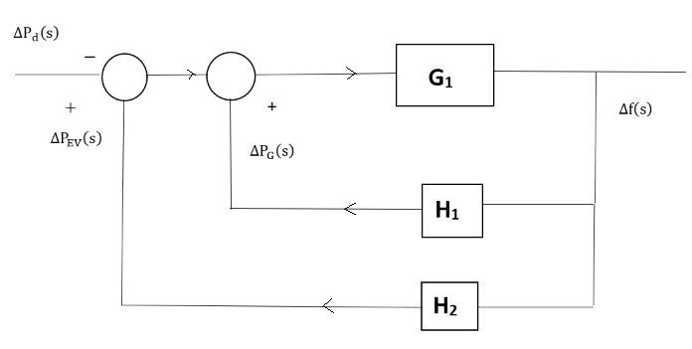

Let us consider,

$$G_{1}=1/{(D+SM)}$$

$$H_{1}= \frac{-[s[k_{p }βα_{0}R+1] +k_{I}βα_{0}R][1+SF_{p}T_{r}]}{Rs\left(1+ST_{g}\right)\left(1+ST_{c}\right)(1+ST_{r})}$$

$$H_{2}=\frac{-[k_{p }βα_{1}k_{ev }s+k_{2}βα_{1}k_{ev }]e^{-sτ}}{s+s^{2}T_{EV}}$$

M=8.8; D=1 $; β=1$; ${ F}_{p}$ = $\frac{1}{6} ;$

$T_{EV}=0.1 ;T_{g }=0.2 ;{ T}_{c}=0.3$; ${ T}_{r}=12$;

$K_{ev }=1$; $K_{p }=0.2$; $K_{I }=0.6$;

$α_{0 }=0.8$; $α_{1 }=0.2 .$

By using **signal flow graph method**, we find the transfer function of the System model of single-area LFC with EV aggregator.

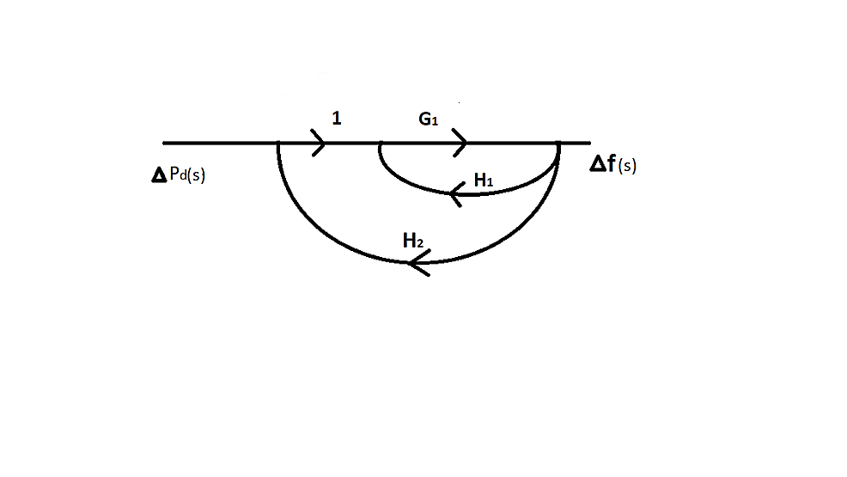

$${ P}_{1=}G_{1}{; ∆}_{1}=1-0=1.$$

$L_{1=}G_{1}H_{1 . }; L_{2=}G_{1}H_{2} ; ∆ =1-\left[H_{1}+H_{2}\right]G_{1}$.

**Maison’s Gain formula:**

Transfer function= $\frac{P_{1}∆_{1}}{∆}$.

= $\frac{G_{1 }× 1}{1-G_{1}[H_{1}{+H}_{2}]}$

= $\frac{1/{D+SM}}{1+\frac{1}{D+SM}[\frac{\left[S\left(k_{p }βα_{0}R+1\right] +k_{I}βα_{0}R\right]\left[1+SF_{p}T_{r}\right]}{Rs\left(1+ST_{g}\right)\left(1+ST_{c}\right)\left(1+ST_{r}\right)}+\frac{-\left[k_{p }βα_{1}k_{ev }s+k_{2}βα_{1}k_{ev }\right]e^{-sτ}}{s+s^{2}T_{EV}}]}$

$$=\frac{\frac{1/{D+SM}}{\begin{aligned}Rs\left(1+ST_{g}\right)\left(1+ST_{r}\right)\left(1+ST_{C}\right)\left(D+SM\right)\left(s+s^{2}T_{EV}\right)]+[\left[s\left[k_{p }βα_{0}R+1\right] +k_{I}βα_{0}R\right]\left[1+SF_{p}T_{r}\right]\left[s+s^{2}T_{EV}\right]+Rs\left(1+ST_{g}\right)\left(1+ST_{c}\right) \\ (1+ST_{r})-[k_{p }βα_{1}k_{ev }s+k_{2}βα_{1}k_{ev }]e^{-sτ}\end{aligned}}}{\left(D+SM\right)\left(1+ST_{g}\right)\left(1+ST_{c}\right)\left(1+ST_{r}\right)(s+s^{2}T_{EV})RS}$$

The closed loop transfer function of the time-delayed load frequency control system relates **Δf(s)**, the incremental frequency variable (output variable) to load disturbance variable **Δ $P_{d}$ (s)** (input variable).

The closed loop transfer function is derived as follows:

G $\left(s\right)=\frac{∆f\left(s\right)}{∆P_{d\left(s\right)}}=\frac{N\left(s\right)}{P\left(s\right)+Q\left(s\right)e^{-sτ}}$

**N(s) = $n_{5}s^{5}$ + $n_{4}s^{4}$ + $n_{3}s^{3}$ + $n_{2}s^{2}$ + $n_{1}s^{1}$ + $n_{0}$**

**= $s^{5}$**[${RT}_{EV}T_{R}T_{c}T_{g}]+s^{4}[R$ [$T_{g}T_{R}T_{EV}$ + $T_{R}T_{c}T_{EV}$ + $T_{c}T_{g}T_{EV}+T_{R}T_{c}T_{g}]+ s^{3}[R$ [ $T_{g}T_{EV}$ + $T_{R}T_{EV}$ + $T_{c}T_{EV}+T_{R}T_{g}+T_{R}T_{c}+T_{c}T_{g}]]{+s}^{2} [R$ [$T_{R}$ + $T_{g}$ + $T_{c}+T_{EV}]]$ +**s**[R]

**P(s) = $p_{6}s^{6}+{ p}_{5}s^{5}$ + $p_{4}s^{4}p_{3}s^{3}$ + $p_{2}s^{2}$ + $p_{1}s^{1}$ + $p_{0}$**

**= $s^{6}\left[MRT_{g}T_{r}T_{c}T_{EV}\right]+s^{5}\left[DRT_{g}T_{r}T_{c}T_{EV} + MR (T_{g}T_{r}T_{c}+T_{r}T_{c}T_{EV}+T_{g}T_{c}T_{EV}+ T_{g}T_{r}T_{EV})\right]$ + $s^{4}\left[DR(T_{g}T_{r}T_{c}+T_{r}T_{c}T_{EV}+T_{g}+T_{g}T_{r}T_{EV})+MR(T_{r}T_{c}+T_{g}T_{c}+T_{g}T_{r}+T_{g}T_{EV}+T_{r}T_{EV}+T_{c}T_{EV})\right]$ + $s^{3}\left[DR(T_{r}T_{c}+T_{g}T_{c}+T_{g}T_{r}+T_{g}T_{EV}+{ T}_{r}T_{EV}+T_{c}T_{EV})+MR\left(T_{r}+T_{c}+T_{g}+T_{EV}\right)+F_{p}T_{r}T_{EV}+α_{0}βRK_{p}F_{p}T_{r}T_{EV}\right]$** + $s^{2}\left[DR\left(T_{r}+T_{c}+ T_{g}+T_{EV}\right)+MR+F_{p}T_{r}+T_{EV}+α_{0}βR\left(K_{p}T_{EV}+K_{p}T_{r}F_{p}+ K_{1}F_{p}T_{r}T_{EV}\right)\right]$**+ $s^{1}\left[DR+1+ α_{0}βR(K_{p}+k_{1}T_{EV}+k_{1}T_{r}F_{p}\right]$ + $\left[α_{0}βRK_{1}\right]$**

**Q(s) = $q_{4}s^{4}$ + $q_{3}s^{3}$ + $qs^{2}$ + $q_{1}s^{1}$ + $q_{0}$**

= ${ s}^{4}\left[α_{1}βRK_{EV}K_{p}T_{g}T_{r}T_{c}\right]$**+ $s^{3}\left[α_{1}βRK_{EV}\left(K_{p}T_{r}T_{c}+K_{p}T_{g}T_{c}+ K_{p}T_{g}T_{r}+K_{1}T_{g}T_{r}T_{c}\right)\right]$ + $s^{2}\left[α_{1}βRK_{EV}\left(K_{p}T_{c}+K_{p}T_{g}+K_{p}T_{r}+{ K}_{1}T_{r}T_{c}{+K}_{1}T_{g}T_{c}+K_{1}T_{r}T_{g}\right)\right]$ + $s^{1}\left[α_{1}βRK_{EV}\left(K_{p}+K_{1}T_{c}+K_{1}T_{r}+K_{1}T_{g}\right)\right]$ $+\left[α_{1}βRK_{EV}K_{1}\right]$**

For stability region and delay margin computations, it is necessary to obtain the characteristic equation of the singlearea LFC-EV system.

The characteristic equation of the singlearea LFC-EV system:

$∆(s,τ$**) $=P\left(s\right)+Q(s)e^{-sτ}$**

$∆(s,τ$**) $=\left[s^{6}\left[MRT_{g}T_{r}T_{c}T_{EV}\right] + s^{5}\left[DRT_{g}T_{r}T_{c}T_{EV} + MR (T_{g}T_{r}T_{c}+ T_{r}T_{c}T_{EV}+ T_{g}T_{c}T_{EV}+ T_{g}T_{r}T_{EV})\right]+s^{4}\left[DR(T_{g}T_{r}T_{c}+T_{r}T_{c}T_{EV}+T_{g}T_{c}T_{EV}+ T_{g}T_{r}T_{EV})+MR(T_{r}T_{c}+T_{g}T_{c}+T_{g}T_{r}+T_{g}T_{EV}+T_{r}T_{EV}+T_{c}T_{EV})\right] + s^{3}\left[DR(T_{r}T_{c}+T_{g}T_{c}+T_{g}T_{r}+T_{g}T_{EV}+{ T}_{r}T_{EV}+T_{c}T_{EV})+MR\left(T_{r}+T_{c}+T_{g}+T_{EV}\right)+F_{p}T_{r}T_{EV}+α_{0}βRK_{p}F_{p}T_{r}T_{EV}\right]+s^{2}\left[DR\left(T_{r}+T_{c}+ T_{EV}\right)+MR+F_{p}T_{r}+T_{EV}+α_{0}βR\left(K_{p}T_{EV}+K_{p}T_{r}F_{p}+ { K}_{1}F_{p}T_{r}T_{EV}\right)\right] + s^{1}\left[DR+1+ α_{0}βR(K_{p}+k_{1}T_{EV}+k_{1}T_{r}F_{p}\right] + \left[α_{0}βRK_{1}\right]\right]$ + $\left[s^{4}\left[α_{1}βRK_{EV}K_{p}T_{g}T_{r}T_{c}\right] + s^{3}\left[α_{1}βRK_{EV}\left(K_{p}T_{r}T_{c}+{ K}_{p}T_{g}T_{c}+ K_{p}T_{g}T_{r}+K_{1}T_{g}T_{r}T_{c}\right)\right] + s^{2}\left[α_{1}βRK_{EV}\left(K_{p}T_{c}+K_{p}T_{g}+{ K}_{p}T_{r}+T_{r}T_{c}{+K}_{1}T_{g}T_{c}+K_{1}T_{r}T_{g}\right)\right] + s^{1}\left[α_{1}βRK_{EV}\left(K_{p}+K_{1}T_{c}+K_{1}T_{r}+K_{1}T_{g}\right)\right] + \left[α_{1}βRK_{EV}K_{1}\right]\right]e^{-sτ}$.**

**The roots of the characteristic equation are:**

$0.05765s^{6}1.06734s^{5}$**+ $6.02351s^{4}11.6329s^{3}$ + $7.20563s^{2}$ + $6.2595s^{1}$ +1.145 = 0**

**S = -9.90431**

**S = -5.36025**

**S = -2.84345**

**S = -0.221403**

**S = -0.0923932 $±$ 0.765317i**

The necessary condition for the single-area LFC-EV system to be asymptotically stable is that all the roots must be in the left half of the s-plane. In consideration of the single delay, the delay margin computation can be done by finding values of τ* for which has roots on the jω-axis. For some finite value of τ*, the characteristic polynomial of Δ (s, τ*) =0 has a root on the imaginary axis at s= $jω_{c}$, the equation of Δ (-s,τ*) =0 will also have the same root on the imaginary axis for the same value of τ* and $ω_{c}$ due to the complex conjugate symmetry of complex roots. That means s= $jω_{c}$ will be a common root of the following equation:

$∆(jω_{c},,τ^{*}$) $= P\left(jω_{c}\right)+Q(jω_{c})e^{-jw_{c}τ^{*}}$ =0

$$∆\left(-jω_{c},τ^{*}\right)= P\left(-jω_{c}\right)+Q(-jω_{c})e^{jw_{c}τ^{*}} =0$$

By eliminating the exponential terms between the above two sub-equations, the following augmented polynomial is obtained:

$W(ω_{c}^{2}$)= P ($jω_{c})$ P ($-jω_{c})-Q(jω_{c}) Q(-jω_{c})=0$

**P(s)**= $p_{6}s^{6}+p_{5}s^{5}{+p}_{4}s^{4}+p_{3}s^{3}+p_{2}s^{2}+p_{1}s^{1}{+p}_{0.}$

**P(-s)** = $p_{6}s^{6}-p_{5}s^{5}-p_{4}s^{4}-p_{3}s^{3}-p_{2}s^{2}-p_{1}s^{1}{-p}_{0}$.

(1)

**P(s) $×$ P(-s)**

= ${ s}^{12}p_{6}p_{6}-s^{11}p_{5}p_{6}$ + ${+s}^{10}p_{4}p_{6}-s^{9}p_{3}p_{6}+s^{8}p_{2}p_{6}-s^{7}p_{1}p_{6}$ + $s^{6}p_{6}p_{0}+s^{11}p_{5}p_{6}+s^{10}p_{5}p_{5}+s^{9}p_{5}p_{4}-s^{8}p_{5}p_{3}$ + $s^{7}p_{5}p_{2}-s^{6}p_{5}p_{1}+s^{10}p_{6}p_{4}-s^{9}p_{5}p_{4}+s^{8}p_{4}p_{4}{-s}^{7}p_{3}p_{4}+s^{6}p_{2}p_{4}-s^{5}p_{1}p_{4}{+s}^{4}p_{0}p_{4}+s^{9}p_{3}p_{6}-s^{8}p_{3}p_{5}+s^{7}p_{3}p_{4}-s^{5}p_{3}p_{2}-s^{4}p_{3}p_{1}+s^{3}p_{3}p_{0}+s^{8}p_{6}p_{2}-s^{7}p_{5}p_{2}$ + $s^{6}p_{4}p_{2}-s^{5}p_{3}p_{2}-s^{4}p_{2}p_{2}{-s}^{3}p_{1}p_{2}+s^{2}p_{0}p_{2}{+s}^{7}p_{6}p_{1}-s^{6}p_{5}p_{1}+s^{5}p_{4}p_{1}-s^{4}p_{3}p_{1}+s^{3}p_{2}p_{1}-s^{2}p_{1}p_{1}+s^{1}p_{0}p_{1}+s^{6}p_{6}p_{0}-s^{5}p_{5}p_{0}{+s}^{4}p_{4}p_{0}-s^{3}p_{3}p_{0}+s^{2}p_{2}p_{0}-s^{1}p_{0}p_{1}{+p}_{0}^{2}$.

**P(s) $×$ P(-s)** = $s^{12}p_{6}p_{6}-s^{10}$ ($p_{5}^{2}-2p_{4}p_{6})+s^{8}$ ($p_{4}^{2}+2p_{2}p_{6}-2p_{5}p_{3})-s^{6}$ ($p_{3}^{2}+2p_{2}p_{4}+2p_{5}p_{1}-2p_{6}p_{0})+s^{4}$ ($p_{2}^{2}-2p_{3}p_{1}+2p_{4}p_{0})-s^{2}$ ($p_{1}^{2}-2p_{2}p_{0})+p_{0}^{2}.$

**Q(s)** = $q_{4}s^{4}{+q}_{3}s^{3}+q_{2}s^{2}+q_{1}s^{1}+q_{0}$.

**(2)**

**Q($-$ s)** = $q_{4}s^{4}{-q}_{3}s^{3}-q_{2}s^{2}-q_{1}s^{1}-q_{0}$.

**Q(s) $×$ Q(-s)**= $s^{8}q_{4}^{2}-s^{7}q_{4}q_{3}+s^{6}q_{4}p_{2}-s^{5}q_{4}q_{1}+s^{4}q_{3}q_{0}+s^{7}q_{3}q_{4}-s^{6}q_{3}q_{3}+s^{5}q_{3}q_{2}-s^{4}q_{3}q_{1}+s^{3}q_{3}p_{0}+s^{6}q_{2}q_{4}-s^{5}q_{3}q_{2}{-s}^{4}q_{2}q_{2}-s^{3}q_{2}q_{1}+s^{2}q_{2}q_{0}+s^{5}q_{1}q_{4}{-s}^{4}q_{3}q_{1}+s^{3}q_{2}q_{1}+s^{2}q_{2}q_{0}-s^{1}q_{1}q_{0}+q_{0}^{2}.$

**Q(s) $×$ Q(-s) = $s^{8}q_{4}^{2}-s^{6}$**($q_{3}^{2}-2q_{4}q_{2})+s^{4}(q_{2}^{2}+2q_{3}q_{0}+2q_{3}q_{1}$) $-s^{2}$

$(q_{1}^{2}{-2q}_{2}q_{0}){+q}_{0}^{2}$.

Substitute s = j $ω_{c},$

P(j $ω$) $×$ P(-j $ω$)-Q(j $ω$) $×$ Q(-j $ω$) = $ω_{c}^{12}p_{6}^{2}-ω_{c}^{10}(p_{5 }^{2}-2p_{6}p_{4}$)+ $ω_{c}^{8}$ ($p_{4}^{2}$ + $2p_{2}p_{6}-2p_{5}p_{3})-ω_{c}^{6}$ ($p_{3}^{2}$ + $2p_{2}p_{4}+2p_{5}p_{1}-2p_{6}p_{0})+ω_{c}^{4}$ ($p_{2}^{2}$- $2p_{3}p_{1}+2p_{4}p_{0})$- $ω_{c}^{2}$ ($p_{1}^{2}$- $2p_{2}p_{0})+p_{0}^{2}$- ${ ω}_{c}^{8}q_{4}^{2}+ω_{c}^{6}\left(q_{3}^{2}-2q_{4}q_{2}\right)-ω_{c}^{4}(q_{2}^{2}+2q_{3}q_{0}-2q_{3}q_{1}$) + $ω_{c}^{2}(q_{1}^{2}$- ${2q}_{2}q_{0})$- $q_{0}^{2}$

By substituting the polynomials of P( $jω_{c}),$ P($-jω_{c}),Q(jω_{c})$ and $Q(-jω_{c})$ into the augmented polynomial $W(ω_{c}^{2}$) of can be represented as

W($ω_{c}^{2})= t_{12}ω_{c}^{12}+ t_{10}ω_{c}^{10}+t_{8}ω_{c}^{8}+t_{6}ω_{c}^{6}+t_{4}ω_{c}^{4}+t_{2}ω_{c}^{2}+t_{0}=0$.

$$t_{12}=p_{6}^{2} .$$

$t_{10}=p_{5}^{2}-$ 2

+ 2–.

.

+ .

.

=0.05765 ; $q_{4}=0.05497;t_{12}=$ 0.003323

${ p}_{5}$ = $1.06734$; $q_{3}=$ 0.62764 $;{ t}_{10}=$ 0.4510

$p_{4}=5.96854{; q}_{2}=$ 2.33573; $t_{8}=$ 12.6955

${ p}_{3}$ = $11.0053{ ; q}_{1}=2.9395$; $t_{6}=$ 69.828

$p_{2 }$ = $4.8699; q_{0}=$ 0.2290; $t_{4}=$-40.217

${ p}_{1}$ = $3.320; t_{2}=$-5.470

${ p}_{0}$ = $0.916; t_{0}=$ 0.78661

**W ($ω_{c}^{2}$) = 0**

**W ($ω_{c}^{2}$) = $0.00323ω_{c}^{2}$**+0.451 $ω_{c}^{2}$ +12.6955 $ω_{c}^{2}+69.828ω_{c}^{2}-40.217ω_{c}^{2}$ ­ - 5.47 $ω_{c}^{2}$ +0.786615=0

$ω_{c}^{2}$ = −103.77

$ω_{c}^{2}$ = −28.3095

$ω_{c}^{2}$ = −8.06205

$ω_{c}^{2}$ = −0.184679

$ω_{c}^{2}$ = 0.091843

$ω_{c}^{2}$ = 0.606242

The real positive roots are $ω_{c}$ = 0.3030561 and $ω_{c}$ = 0.7786154. Calculating the delay margin for each positive root and the minimum of those is taken as the system delay margin $τ^{*}$.

The stability delay margin is ${ τ}^{*}=0.6018600127$

**COMPUTATION OF STABILITY REGIONS**

To identify the boundary of the stability region in the parameter space of PI controller, ($K_{p}-K_{I}$)-plane for a given time delay τ, s = j $ω_{c}$ and the crossing frequency $ω_{c}$ > 0 is substituted into (2). The PI controller gains are then separated to obtain a new equation as follows

P(s) = $p_{6}s^{6}+ p_{5}s^{5}$ + $p_{4}s^{4}+p_{3}s^{3}$ + $p_{2}s^{2}$ + $p_{1}s^{1}$ + $p_{0}$

$P\left({jω}_{c}\right)=p_{6}ω_{c}^{6}$ + $p_{5}jω_{c}^{5}+p_{4}ω_{c}^{4}-p_{3}jω_{c}^{3}– p_{2}ω_{c}^{2}+p_{1}ω_{c}+p_{0}$

$P\left({jω}_{c}\right)=$ [- $p_{6}ω_{c}^{6}+ p_{4}ω_{c}^{4}– p_{2}ω_{c}^{2}+p_{0}$] +j[$p_{5}ω_{c}^{5}-p_{3}jω_{c}^{3}+p_{1}ω_{c}$}

Q(s) = $q_{4}s^{4}$ + $q_{3}s^{3}$ + $qs^{2}$ + $q_{1}s^{1}$ + $q_{0}$

$$Q\left({jω}_{c}\right)=q_{4}ω_{c}^{4}-q_{3}jω_{c}^{3}– q_{2}ω_{c}^{2}+q_{1}ω_{c}+q_{0}$$

$Q\left({jω}_{c}\right)=[q_{4}ω_{c}^{4}– q_{2}ω_{c}^{2}+q_{0}$] +j [$q_{3}ω_{c}^{3}+q_{1}ω_{c}$]

${ e}^{-st}$ = $e^{{-jω}_{c}t}=cos\left(ω_{c}t\right)-j sin\left(ω_{c}t\right)$

$$P\left({jω}_{c}\right)+Q\left({jω}_{c}\right)e^{{-jω}_{c}t}=0$$

$[q_{4}ω_{c}^{4}– q_{2}ω_{c}^{2}+q_{0}$] +j[$q_{3}ω_{c}^{3}+q_{1}ω_{c}$] $cos\left(ω_{c}t\right)-j sin\left(ω_{c}t\right)=-P\left({jω}_{c}\right)$

$[q_{4}ω_{c}^{4}– q_{2}ω_{c}^{2}+q_{0}$*

] $cos\left(ω_{c}t\right)-[jq_{4}ω_{c}^{4}– q_{2}ω_{c}^{2}+q_{0}$] $sin\left(ω_{c}t\right)+$ j[$-q_{3}ω_{c}^{3}+q_{1}ω_{c}$] $-j sin\left(ω_{c}t\right)$*+ j[${-q}_{3}ω_{c}^{3}+q_{1}ω_{c}$] $cos\left(ω_{c}t\right)$ =

-[ $P\left({jω}_{c}\right)$ R + j $P\left({jω}_{c}\right)Q]$

$q_{4}ω_{c}^{4}– q_{2}ω_{c}^{2}+q_{0}$] $cos\left(ω_{c}t\right)+$ [$-q_{3}ω_{c}^{3}+q_{1}ω_{c}$] $sin\left(ω_{c}t\right)$ = $P\left({jω}_{c}\right)R$

$q_{4}ω_{c}^{4}– q_{2}ω_{c}^{2}+q_{0}$] $cos\left(ω_{c}t\right)+$ [$-q_{3}ω_{c}^{3}+q_{1}ω_{c}$] $sin\left(ω_{c}t\right)$ = $-P\left({jω}_{c}\right)R$

$q_{4}ω_{c}^{4}– q_{2}ω_{c}^{2}+q_{0}$] $cos\left(ω_{c}t\right)-$ [$-q_{3}ω_{c}^{3}+q_{1}ω_{c}$] $sin\left(ω_{c}t\right)$ = $-P\left({jω}_{c}\right)I$

$$q_{4}^{,}= K_{p}\left[α_{1}βRK_{EV}T_{g}T_{r}T_{c}\right]$$

${ q}_{3}^{,}$ = $\left[α_{1}βRK_{EV}\left(K_{p}T_{r}T_{c}+K_{p}T_{g}T_{c}+K_{p}T_{g}T_{r}\right)\right]$

$q_{3}^{,,}$ = $K_{I}\left[α_{1}βRK_{EV}T_{g}T_{r}T_{c}\right]$

$q_{2}^{,}$ = $\left[α_{1}βRK_{EV}\left(K_{p}T_{c}+K_{p}T_{g}+K_{p}T_{r}\right)\right]$

$q_{2}^{,,}$ = $K_{I}\left[α_{1}βRK_{EV}\left(T_{r}T_{c}+T_{g}T_{c}+T_{g}T_{r}\right)\right]$

$q_{1}^{,}$ = $\left[α_{1}βRK_{EV}K_{p}\right]$

$$q_{1}^{,,}=K_{I}\left[α_{1}βRK_{EV}T_{g}T_{r}T_{c}\right]$$

$q_{0}^{,,}$ = $K_{I}\left[α_{1}βRK_{EV}K_{I}\right]$

$p_{6}$ = $\left[MRT_{g}T_{r}T_{c}T_{EV}\right]$

$p_{5}$ = $\left[DRT_{g}T_{r}T_{c}T_{EV} + MR (T_{g}T_{r}T_{c}+T_{r}T_{c}T_{EV}+{ T}_{g}T_{c}T_{EV}+ T_{g}T_{r}T_{EV})\right]$

$$p_{4}=\left[DR(T_{g}T_{r}T_{c}+T_{r}T_{c}T_{EV}+T_{g}T_{c}T_{EV}+T_{g}T_{r}T_{EV})+MR(T_{r}T_{c}+T_{g}T_{c}+T_{g}T_{r}+T_{g}T_{EV}+T_{r}T_{EV}+T_{c}T_{EV})\right]$$

$$p_{3}=\left[DR(T_{r}T_{c}+T_{g}T_{c}+T_{g}T_{r}+T_{g}T_{EV}+{ T}_{r}T_{EV}+T_{c}T_{EV})+MR\left(T_{r}+T_{c}+T_{g}+T_{EV}\right)+F_{p}T_{r}T_{EV}\right]$$

$p_{3}^{,}$ = $K_{p}{[α}_{0}βRK_{p}F_{p}T_{r}T_{EV}];p_{2}=DR\left(T_{r}+T_{c}+T_{g}+T_{EV}\right)+MR+F_{p}T_{r}+T_{EV}$

$p_{2}^{,}$ = $K_{p}{[α}_{0}βR\left[F_{p}T_{r}+T_{EV}\right]];p_{2}^{,,}={K_{I}[α}_{0}βRF_{p}T_{r}T_{EV}]$

$p_{1}$ = DR+1

$p_{1}^{,}$ = ${ K}_{p}{[α}_{0}βR$ [+1]]

$p_{1}^{,,}$ = $K_{I}{[α}_{0}βR\left[F_{p}T_{r}+T_{EV}\right]]$

$p_{0}^{,,}$ = ${ K}_{p}{[α}_{0}βR$]

$q_{4}ω_{c}^{4}– q_{2}ω_{c}^{2}+q_{0}$] $cos\left(ω_{c}t\right)+$ [$-q_{3}ω_{c}^{3}+q_{1}ω_{c}$] $sin\left(ω_{c}t\right)= -$ [- $p_{6}ω_{c}^{6}+ p_{4}ω_{c}^{4}– p_{2}ω_{c}^{2}+p_{0}$].

[$-q_{3}ω_{c}^{3}+q_{1}ω_{c}$] $cos\left(ω_{c}t\right)$- $q_{+4}ω_{c}^{4}– q_{2}ω_{c}^{2}+q_{0}$] $sin\left(ω_{c}t\right)$ =- [$p_{5}ω_{c}^{5}-p_{3}jω_{c}^{3}+p_{1}ω_{c}$]

**REAL PART**

$k_{p}[\left[q_{4}^{,}ω_{c}^{4} - q_{2}^{,}ω_{c}^{2}\right]cos$ ($ω_{c}+1$) $\left[-q_{3}^{,}ω_{c}^{3}- q_{1}^{,}ω_{c}\right]sin$ ($ω_{c}+1$)]

$k_{I}[\left[-q_{2}^{,,}ω_{c}^{2}+q_{0}^{,,}\right]cos$ ($ω_{c}+1$) $\left[-q_{3}^{,,}ω_{c}^{3}- q_{1}^{,,}ω_{c}\right]sin$ ($ω_{c}+1$)]

= [- $p_{6}ω_{c}^{6}+ p_{4}ω_{c}^{4}– p_{2}ω_{c}^{2}k_{p}[-p_{2}^{,}ω_{c}^{2}] k_{I}[\left[-p_{2}^{,,}ω_{c}^{2}+p_{0}^{,,}\right]$.

$k_{p}[-p_{2}^{,}ω_{c}^{2}+q_{4}^{,}ω_{c}^{4} cos$ ($ω_{c}+1$) – $q_{2}^{,}ω_{c}^{2}cos$ ($ω_{c}+1$) – $q_{3}^{,}ω_{c}^{3}sin$ ($ω_{c}+1$) + $q_{1}^{'}ω_{c}sin$ ($ω_{c}+1$)] + $k_{I}[-p_{2}^{''}ω_{c}^{2}+p_{0}^{''}-q_{2}^{''}ω_{c}^{2} cos$ ($ω_{c}+1$) + ${ q}_{0}^{''}cos$ ($ω_{c}+1$) – $q_{3}^{''}ω_{c}^{3}sin$ ($ω_{c}+1$) + $q_{1}^{''}ω_{c}sin$ ($ω_{c}+1$)] +[ $p_{6}ω_{c}^{6}– p_{4}ω_{c}^{4}+p_{2}ω_{c}^{2}$]. $k_{p}A_{1}\left(ω_{c}\right)+ k_{I}B_{1}\left(ω_{c}\right)$ = - $C_{1}\left(ω_{c}\right)$

**IMAGINARY PART**

() + (() + ()]

=-[

() +() +() + () +() - ()]

=[ ]

= -

+ = 0

From 3 and 4 we get

$$k_{p}= \frac{B_{1}\left(ω_{c}\right)C_{2}\left(ω_{c}\right)-B_{2}\left(ω_{c}\right)C_{1}\left(ω_{c}\right)}{A_{1}\left(ω_{c}\right)B_{2}\left(ω_{c}\right)-A_{2}\left(ω_{c}\right)B_{1}\left(ω_{c}\right)}→(5)$$

From 3 and 4 we get

A1()+ B1()+ C1 ()=0

A2()+ B2()+ C2 ()=0

The coefficients are

A1 () = -pי22 + qי44cos(t) – qי22cos(t) – qי33sin(t) + qי1ωcsin(t)

B1() = -pיי22 + pיי0 – qיי22cos(t)+qיי0cos(t) – qיי3ωc3sin(t) + qיי1ωcsin(t)

C1 () = -p6 + p4 – p22

A2() = -pי33 + pי1 – qי33cos (t) + qי44sin(t) + qי22sin(t)

B2() = pיי1– qיי33cos(t) + qיי1cos(t) + qיי22sin(t) – qיי0sin(t)

C2() = p55 – p33 + p1

It should be noted that p6, p5 and p4 coefficients in the above equations are those given in (1) and q3, q4 and q3 coefficients in the above equations are those given in (2) on the other hand the coefficients of pיי and qיי in the above equations corresponds to the remaining terms of p and q containing KI, respectively.The stability boundary obtained by (10) is called as complex root boundaries (CRBs) of the LFC-EV system. It is noted that a real root may cross the jω axis across the origin. Moreover, it can be observed that such a stability change occurs only for KI=0, defining another boundery called as Real Root Boundary (RRB) locus. As a result, the (KP, KI)-plane is divided into stable and unstable regions by the RRB locus KI =0 and the CRB locus,obtained by (7) which will be discussed in detail in next chapter.